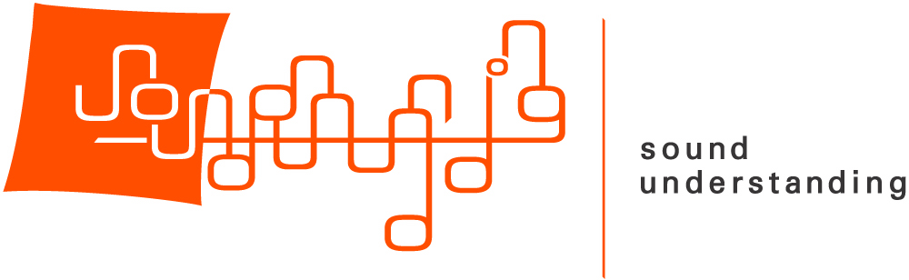

DAAD Alumni Association of the U.S.A.
Sponsorship Form

CONTACT INFORMATION
Name:
Name acknowledged in concert program (if other than above):
Address:
Telephone Number: ___________________ Email:

We are able to accept check payments and online payments (by credit card or Paypal account). Online payments can be made at: www.daad-alumni-usa.org/support-5

Please return this form in all cases, even if you have used the website to submit your contribution.

I wish to make a donation to the DAAD Alumni Association at the following level:

□ GOLD Sponsorship $5,000
□ SILVER Sponsorship $2,000
□ BRONZE Sponsorship $1,000
□ SUPPORTER $500
□ Other $_____________

Payment Method
Check Attached □ I submitted my payment online □

Contributions are tax-deductible to the extent permitted by law. Please make checks payable to DAAD Alumni Association, Inc. and mail it, along with this form, to:
DAAD Alumni Association Inc.
c/o DAAD
871 UN Plaza
New York, NY 10017

We must receive this form by March 1st, 2025.

THANK YOU!

